Election System

***Who can access this system : voters , admin***

***Description:***

*At the beginning we have a vote system for Kurdistan people and we solve that every person can vote online and we don’t need to go to voting in a school or a specific place it use full for that and lets we talk about the website first every person must have his/her username and password to sign in into the system and voting if she or he doesn’t have user name and password they must signup or register into the system and each person have his/her own id and the users must sign their age into the system because the age under 18 years can not vote in the system and it a national concept but we have a problem the system doesn’t know if you’re under 18 or not because of that we must make a barcode to read the information about the users we must user personal card or information card to make a successful voting this is one of disadvantages of this system after we sign in to the system we see the page that we have tow part first part is the party that we can select one of the party then we have the other part we have candidate the we can select one candid for the party that we selected it after that we click on vote and this vote save in the database after that in the form login we have two button one of the is that you look for your name in the voting list if your age under 18 your name is doesn’t show but if you’re age above 18 your name is shown in the page and the another button is information about the voting that how you can vote and who can vote and the voting system in which country is done and how we can see the result of the election system? The answer is that only the admin of the system can see the result of voting the users cant see the result*

*Election system*

admin

users

*Database design*

*in database design we have three table one for users and admin for login into the system or register into the system and if we sign into the system the username and password go to the database and check if this name and password is exist it login into the user or admin page otherwise it doesn’t login into the system*

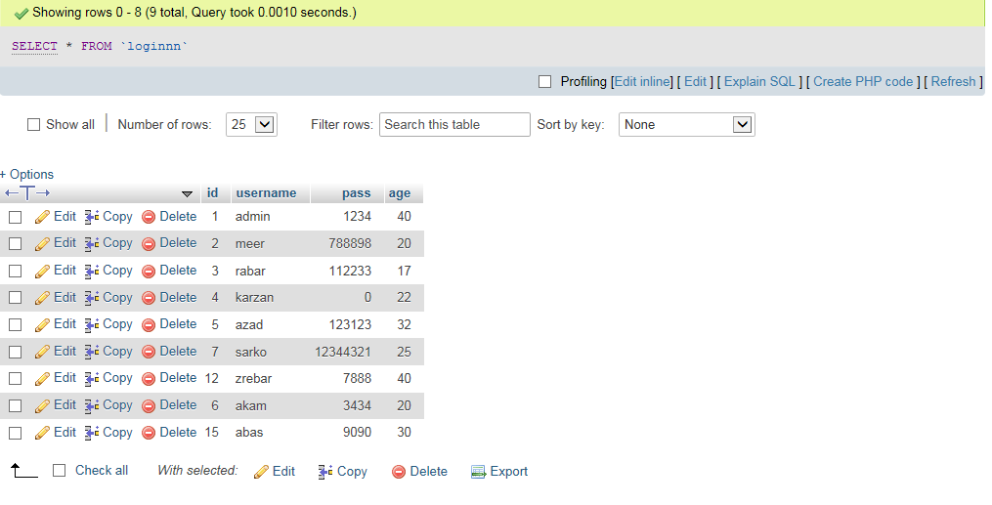

*At last one of the web application that failed :*

Shelby County election night did not go as planned, official admits

Election officials say much of what happened in Shelby County can be attributed to old equipment, a dash of human error and a county-operated website failure that was outside their purview.

And despite the speed at which election results were posted elsewhere, Shelby County has its own challenges.

"I understand people want the information immediately, but we are the largest county in Tennessee, we have the most early voting locations and geographically, we're enormous," Phillips said.

It isn't the first time Shelby County has had problems with slow vote results. Past problems, many before Phillips was administrator, were blamed on voting discrepancies, malfunctioning machines, glitches in scanning equipment and other reasons.

Issues with results Thursday night followed an election day with only a few very minor problems, Phillips said. There was a poll worker who plugged equipment into a dead outlet and another site where a printer stopped working, but was quickly replaced.

"It was a pretty trouble-free, even though I'm kind of disappointed in the turnout," Phillips said of the 27 percent of registered voters who cast ballots.

Phillips planned to release numbers about an hour after the last voter voted, which was about 7:30 p.m.

That didn't happen

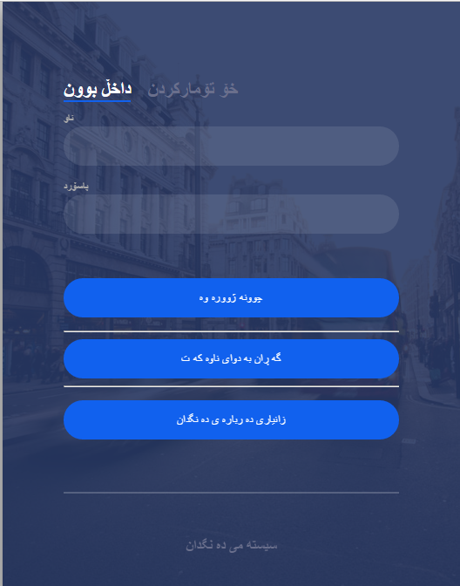

<label for="tab-1" class="tab">داخڵ بوون</label>

<input id="tab-2" type="radio" name="tab" class="sign-up"><label for="tab-2" class="tab">خۆ تۆمارکردن</label>

<div class="login-form">

<div class="sign-in-htm">

<div class="group">

<span class = "error"> <?php echo $nameErr;?></span>

<label for="user" class="label">ناو</label>

<input id="user" type="text" class="input" name="name">

</div>

<div class="group">

<span class = "error"> <?php echo $passwordErr;?></span>

<label for="pass" class="label">پاسۆرد</label>

<input id="pass" type="password" class="input" data-type="password" name="password">

</div>

<br><br>

<div class="group">

<input type="submit" class="button" value="چوونه ژووره وه" name="sub">

</div>

<hr>

<div class="group">

<input type="submit" class="button" value="گه ڕان به دوای ناوه که ت" name="test">

<hr>

</div >

<div class="group">

<input type="submit" class="button" value="زانیاری ده رباره ی ده نگدان" name="information">

</div>

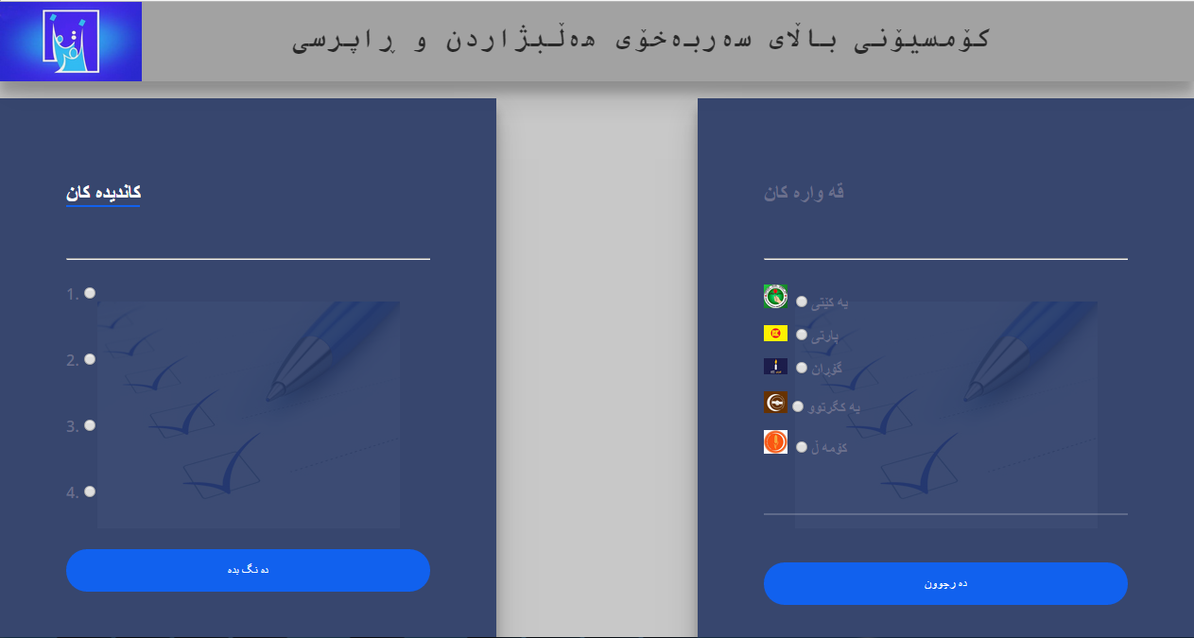

<div class="title">

<img src="comsion.jpg" width="150px" class="imageContainer" >

<pre>

کۆمسیۆنی باڵای سەربەخۆی هەڵبژاردن و ڕاپرسی

</pre>

</div>

<br>

<div class="user">

<div class="login-html">

<input id="tab-1" type="radio" name="tab" class="sign-in" checked>

<label for="tab-1" class="tab">قه واره کان</label>

<input id="tab-2" type="radio" name="tab" class="sign-up"><label for="tab-2" class="tab"></label>

<div class="login-form">

<div class="sign-in-htm">

<div class="group">

<br>

<span class = "error"> <?php echo $nameErr;?></span>

<br><hr><br>

<img src="yakety.jpg" width="25px"> <input value="yakety" type="radio" name="hizb" selected="selected">یه کێتی

</div>

<div class="group">

<img src="party.jpg" width="25px"> <input value="party" type="radio" name="hizb" selected=selected>پارتی

</div>

<div class="group">

<img src="goran.jpg" width="25px"> <input value="goran" type="radio" name="hizb" selected=selected>گۆڕان

</div>

<div class="group">

<img src="yakgrtw.jpg" width="25px"><input value="yakgrtw" type="radio" name="hizb" selected=selected>یه کگرتوو

</div>

<div class="group">

<img src="komal.jpg" width="25px"> <input value="komal" type="radio" name="hizb" selected=selected>کۆمه ڵ

</div>

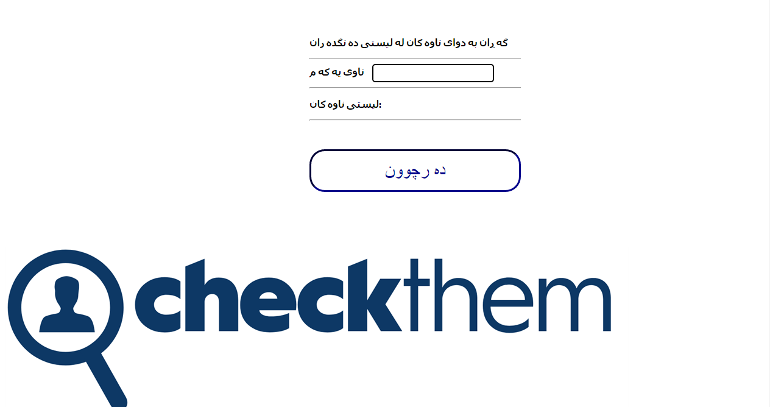

<form>

<div class="search">

<p ><b>گه ڕان به دوای ناوه کان له لیستی ده نگده ران</b></p>

<hr>

<b> <label for="user" class="padd" >ناوی یه که م</label></b>

<input id ="user " type="text" onkeyup="showHint(this.value)" class="a">

<hr>

<p><b>لیستی ناوه کان</b>: <span id="txtHint"></span></p>

<hr> <br>

<div class="group">

<h2><button class="button" ><a href = "logout.php">ده رچوون</a></button></h2>

</div>

</div>

<img src="check.png">

<div class="hr"></div>

</form>

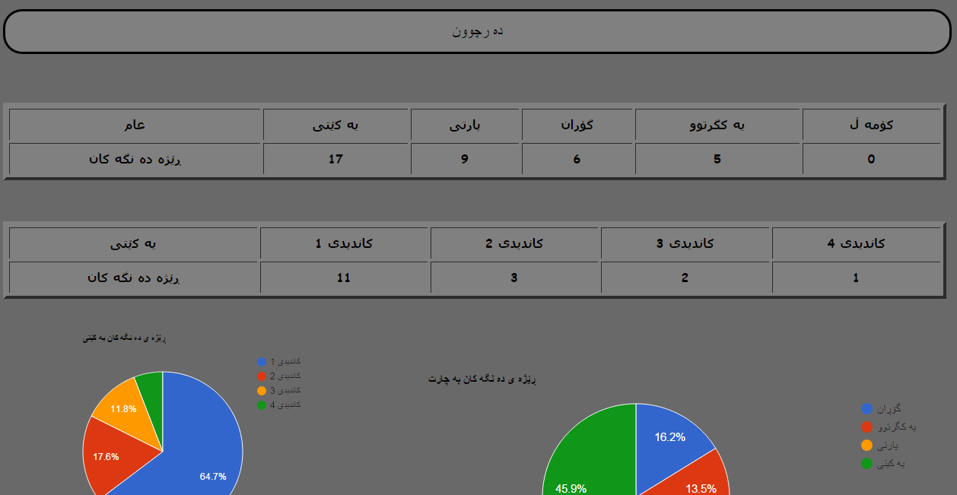

<div >

<img src="comsion.jpg" width="150px" class="imageContainer" >

<pre>کۆمسیۆنی باڵای هه ڵبژاردنه کان</pre>

</div>

<div class="exitt">

<h2><button class="button" ><a href = "logout.php">ده رچوون</a></button></h2>

</div>

<br><br>

<table width="1240" border="4" border-radius="3px" cellspacing="4" cellpadding="8" class="table">

<tr>

<td align="center" class="a"><strong > عام</strong></td>

<td align="center" class="a"><strong >یه کێتی</strong></td>

<td align="center" class="a"><strong>پارتی</strong></td>

<td align="center" class="a"><strong>گۆڕان</strong></td>

<td align="center" class="a"><strong>یه کگرتوو</strong></td>

<td align="center" class="a"><strong>کۆمه ڵ</strong></td>

</tr>

<tr>

<td align="center" class="a"><strong>ڕێژه ده نگه کان</strong></td>

<td align="center" class="a"><strong><?php echo $yaketyyy; ?></strong></td>

<td align="center" class="a"><strong><?php echo $partyyy; ?></strong></td>

<td align="center" class="a"><strong><?php echo $gorannn; ?></strong></td>

<td align="center" class="a"><strong><?php echo $yakgrtwww; ?></strong></td>

<td align="center" class="a"><strong><?php echo $komalll; ?></strong></td>

</tr>

</table>

<br><br><br>